library(osmdata)

library(rgdal) ; library(maptools) ; library(rgeos)

q0 <- opq(bbox = "Bern, Switzerland", timeout = 60)

q1 <- add_osm_feature(q0, key = 'building', value = "hospital")

x <- osmdata_sp(q1)

library(leaflet)

spChFIDs(x$osm_polygons) <- 1:nrow(x$osm_polygons@data)

cent <- gCentroid(x$osm_polygons, byid = TRUE)

leaflet(cent) %>% addTiles() %>% addCircles()

Here we plot the building centroids.

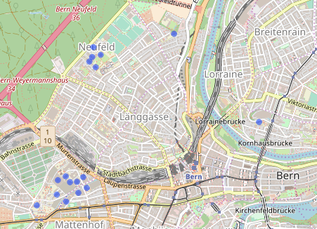

Each point represents a hospital building. We don’t particularly care about the buildings themselves though. We want to create hospitals. To do so, we try a 150m buffer around each centroid.

buff <- gBuffer(cent, byid = TRUE, width = 0.0015)

leaflet(cent) %>% addTiles() %>% addPolygons(data = buff, col = "red") %>% addCircles()

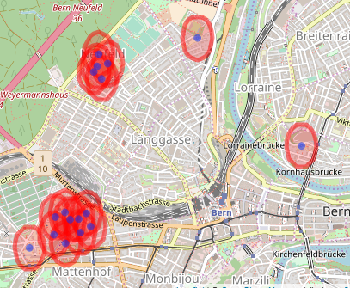

We then want to merge the buffers into, in this case, four groups. This is the point that doesn’t seem to be implemented anywhere that I could see (I also tried QGIS but that just created one big feature, rather than many small ones). My approach is to get the unique sets of intersections, add them as a variable to the buffer and unify the polygons.

buff <- SpatialPolygonsDataFrame(buff, data.frame(row.names = names(buff), n = 1:length(buff)))

gt <- gIntersects(buff, byid = TRUE, returnDense = FALSE)

ut <- unique(gt)

nth <- 1:length(ut)

buff$n <- 1:nrow(buff)

buff$nth <- NA

for(i in 1:length(ut)){

x <- ut[[i]]

buff$nth[x] <- i

}

buffdis <- gUnaryUnion(buff, buff$nth)

leaflet(cent) %>% addTiles() %>% addPolygons(data = buffdis, col = "red") %>% addCircles()

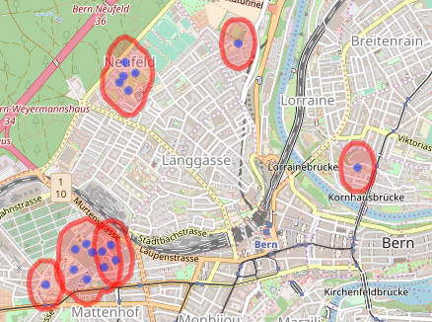

As you see, it almost worked. The lower left group is composed of three polygons. Doing the same process again clears it (only code shown). Large jobs might need more iterations (or larger buffers). The final job is to get the hospital centroids.

gt <- gIntersects(buffdis, byid = TRUE, returnDense = FALSE)

ut <- unique(gt)

nth <- 1:length(ut)

buffdis <- SpatialPolygonsDataFrame(buffdis, data.frame(row.names = names(buffdis), n = 1:length(buffdis)))

buffdis$nth <- NA

for(i in 1:length(ut)){

x <- ut[[i]]

buffdis$nth[x] <- i

}

buffdis <- gUnaryUnion(buffdis, buffdis$nth)

leaflet(cent) %>% addTiles() %>% addPolygons(data = buffdis, col = "red") %>% addCircles()

buffcent <- gCentroid(buffdis, byid = TRUE